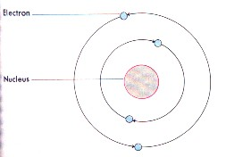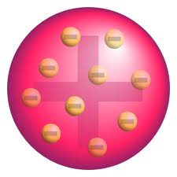

**Niels Bohr**

Planetary Model

Electrons orbit the nucleus in energy levels

**Ernest Rutherford**

Nuclear Model

Used gold foil experiments to show that atoms had a nucleus of positively charged particles.

**J.J. Thomson (British)**

Plum Pudding Model

Atoms have positive and negative charged parts.

**John Dalton (British)**

Solid Ball Model

An element is made up of only one type of atom.

**Democritus (Greek)**

Matter than cannot be broken down into smaller parts is called an atom.

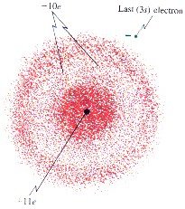

**Erwin Schrodinger**

Electron Cloud Model

Electrons do not have a set path around the nucleus