**TOPOGRAPHIC MAPS**

A **topographic map** is a **two-dimensional** representation of a portion of the **three-dimensional** surface of the earth.

**Topography** is the **shape** of the land surface.

Topographic maps exist to **represent** the land surface.

*Topographic maps usually portray (show) both natural and man-made features.*

*They show and name features including* ***mountains****, valleys, plains,* ***lakes****, rivers and vegetation.*

*Topographic maps are used for engineering, energy exploration,* ***natural resource*** *conservation, environmental management, public works design, commercial and residential planning, and outdoor activities like hiking, camping, and* ***fishing****.*

**Properties of Topographic Maps**

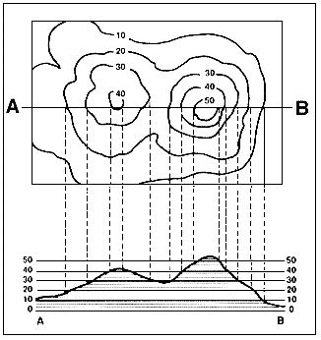***Map Scale:***Maps come in a variety of scales, covering areas ranging from the entire earth to a city block (or less).

**Views:**

**Contour lines:**

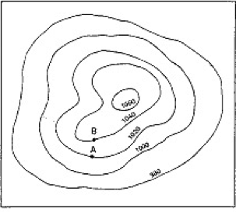

**Contour Lines:** Contour lines are used to determine **elevations**.

If you walk along a contour line you neither **gain or lose** elevation.

**Rules:**

* **Contour lines do not cross, branch, or touch each other.**
* **Contours that are spaced close together represent steep slopes.**
* **Contour lines that are spaced far apart represent gentle slopes.**
* **All points on a contour line are of equal elevation**

**Views:**

Aerial (Overhead) View:

Profile (Side) View:

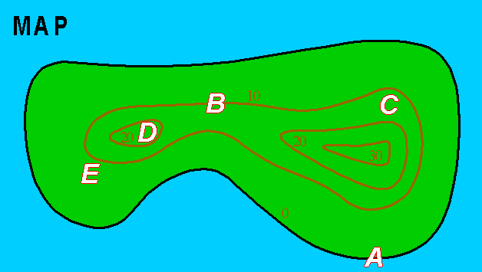

Elevation at Point A _______

Elevation at Point B _______

Elevation at Point C _______

Elevation at Point D _______

Elevation at Point E _______

**Landforms:**

**Topographic maps can show islands, canyons, mountains, and deltas.**

*Label each map below with the landform it shows:*

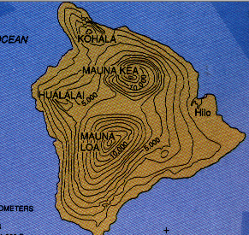 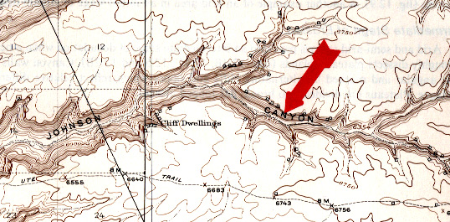



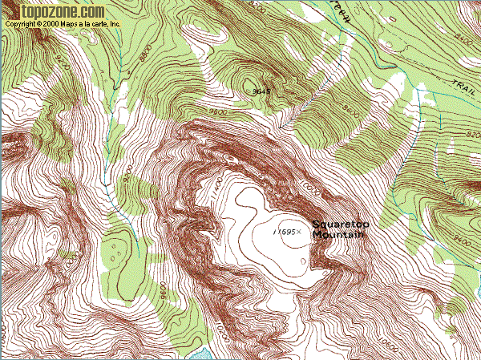 

**Weathering:** The physical or chemical break down of rock due to water, wind, or ice

**Erosion:** The relocation of sediment by wind, water or ice

If weathering and erosion occur, contour lines on a topographic map may change.

For a **mountain**, contour lines may become more **spread out**. This happens as the elevation becomes **less steep** as rock material is broken down (weathering) and carried away (erosion).

For a **canyon**, contour lines may become **closer together**. This happens as the elevation becomes **more steep** as rock material is broken down (weathering) and carried away (erosion).

**Deposition:** Solid fragments of rock that come from the weathering of rock, are eroded, and then deposited by wind, water, ice, or gravity.

Deposition creates earth features such as **deltas** at the mouth of rivers.

As sediments are carried by rivers, they may build up and create **deltas** at the mouth of a river

Topographic maps of the area may show evidence of delta formation as contour lines form a “V” shape

*Draw in the river on the topographic map below and add an arrow to show its direction.*

